1 INTRODUCTION

1.1 Overview:

Develop an app for the property management where buyer can order his requirements and get the appropriate details of the property. According to his interest just provide him with some discounts up to what extent he can get the discount. Also track whether he is interested in taking the loan available for so just calculate how much loan amount user can get it.

1.2 Purpose

Provide the security for two different profiles like for marketing and sales team. Then finally create the reports and dashboard so there will be clear view just get the reports on the count of loan passed getting the property purchased close the deal.

2 Problem Definition & Design Thinking

2.1 Empathy Map

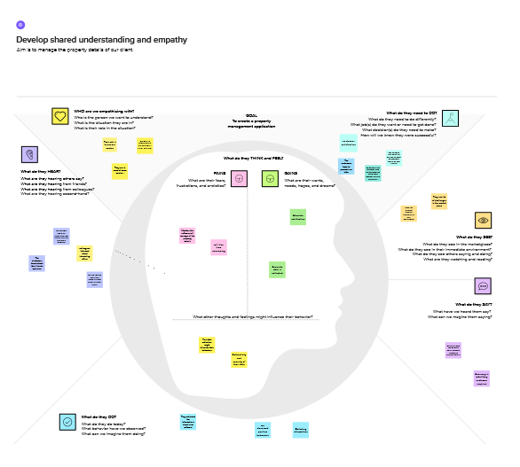

2.2 Ideation & Brainstorming Map

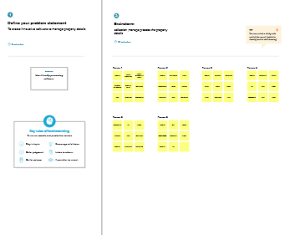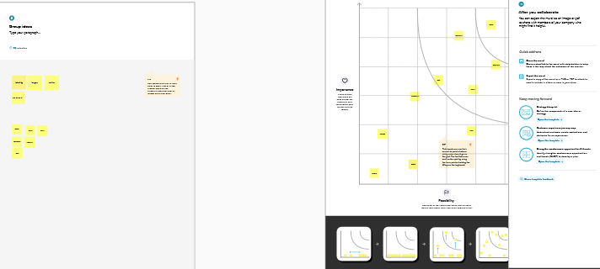

3 RESULT

3.1 Data Model:

|  |  |
| --- | --- |
| Object Name | Fields in the object |
| Lead | |  |  | | --- | --- | | Lead | Auto Number | | State | Text | | City | Pick list | | Email | Text | | Phone | Number | |
| Buy | |  |  | | --- | --- | | Property Type | Pick list | | Discount | Percent | | State | Text | | City | Pick list | | Annual Amount | Number | |
| Rent | |  |  | | --- | --- | | Rent | Number | | Rental City | Text | | BHK | Pick list | |
| Loan | |  |  | | --- | --- | | Loan ID | Auto Number | | Interest Rate | Currency | | Term | Number | | Annual loan | Number | | Total Loan Installments | Number | | Loan Repayment | Number | | Loan Amount | Formula | |

3.2 Activity & Screenshot

Milestone 1-Salesforce

Sales force is a customer success platform, designed to help sell, service, and market, analyze, and connect with the customers.

Milestone 2-Object

Sales force objects are database tables that permit to store data that is specific to an organization .

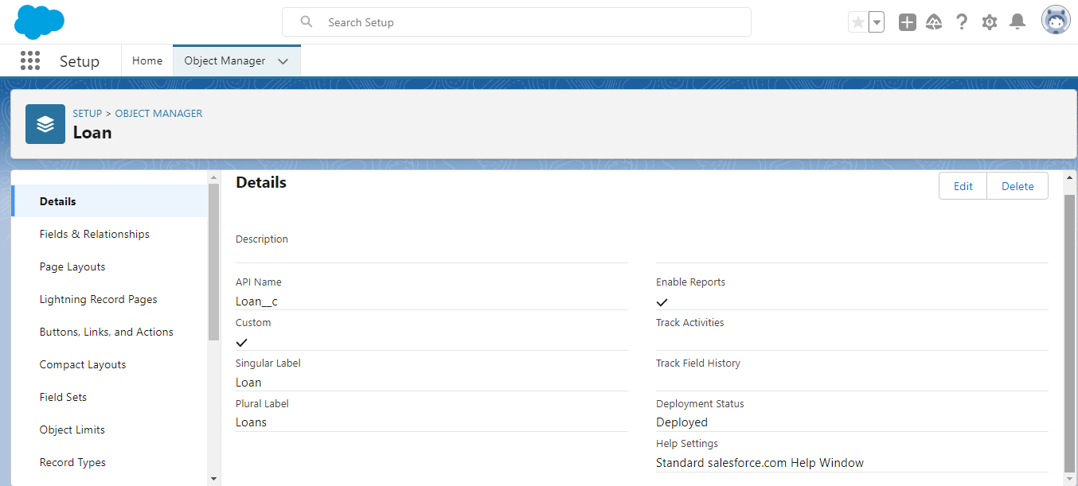

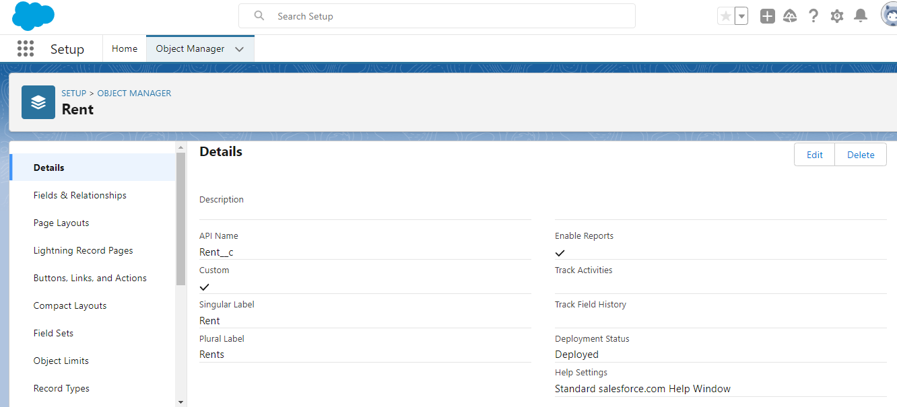

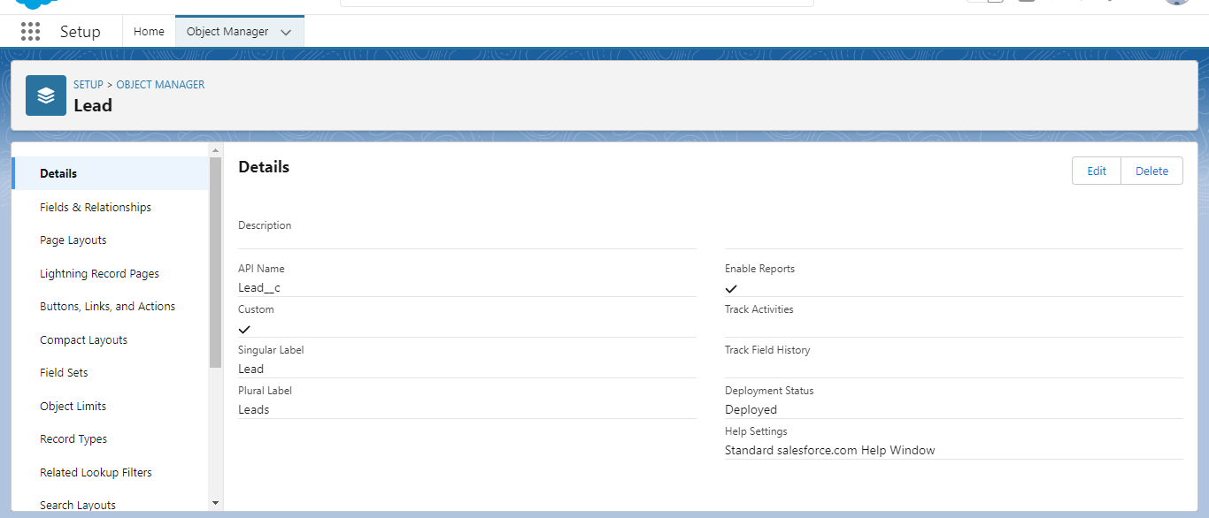

Milestone 3-Tab

A tab is like a user interface that is used to build records for objects to view the records in the objects.

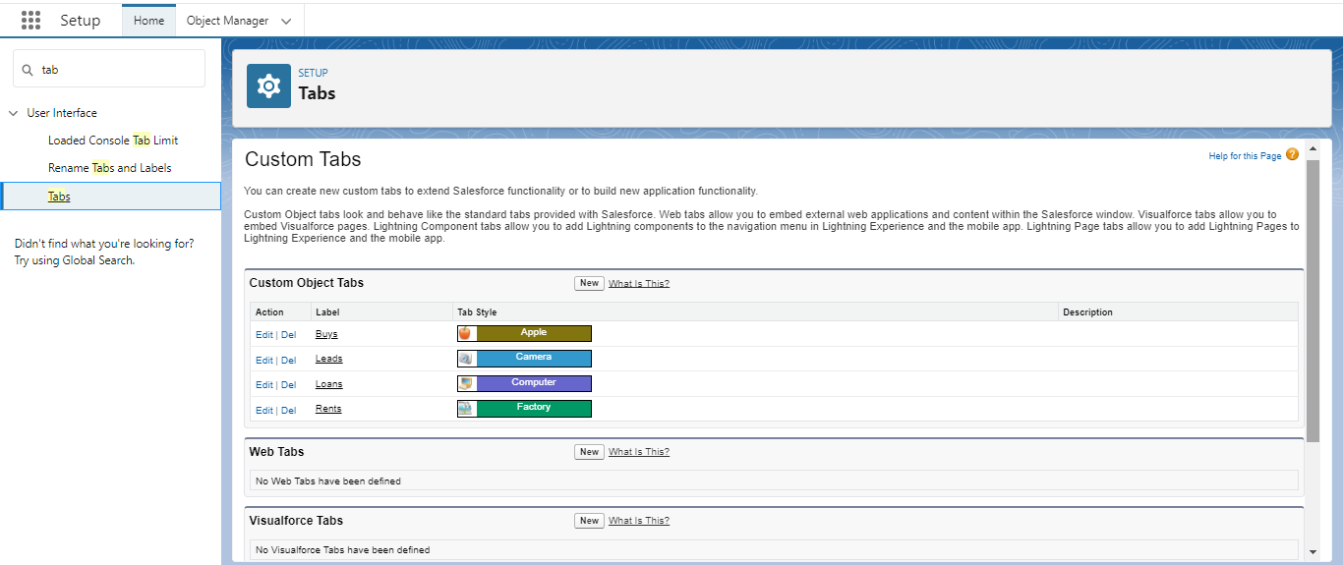

Milestone 4- The Lightning app

An app is a collection of items that work together to serve a particular function. In Lightning

Experience, Lightning apps give users access to sets of objects, tabs, and other items all in one

Convenient bundle in the navigation bar.

Lightning apps brand the apps with a custom color and logo. We can even include a

utility bar and Lightning page tabs in the Lightning app. Members of org can work more

efficiently by easily switching between apps.

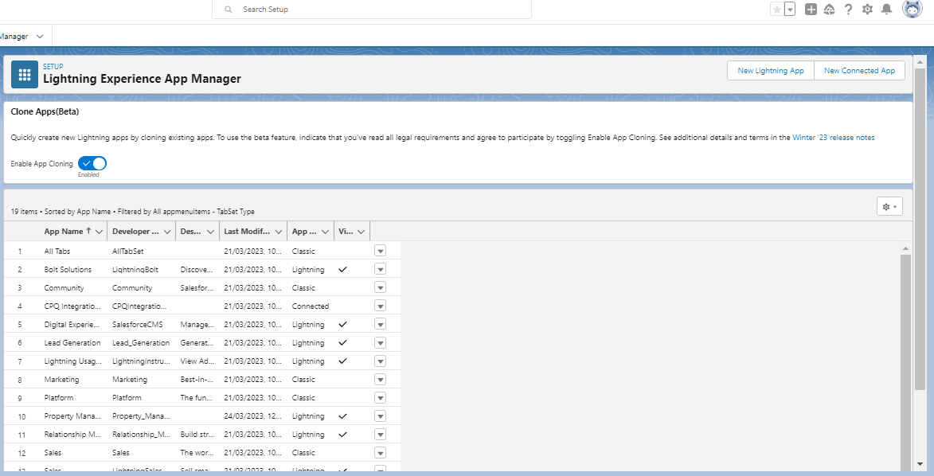

Milestone 5-Fields

When we discuss Sales force, Fields represent the data stored in the columns of a relational

database. It can also hold any valuable information that is required for a specific object. Hence,

the overall searching, deletion, and editing of the records become simpler and quicker.

Types of Fields

● Standard Fields

● Custom Fields

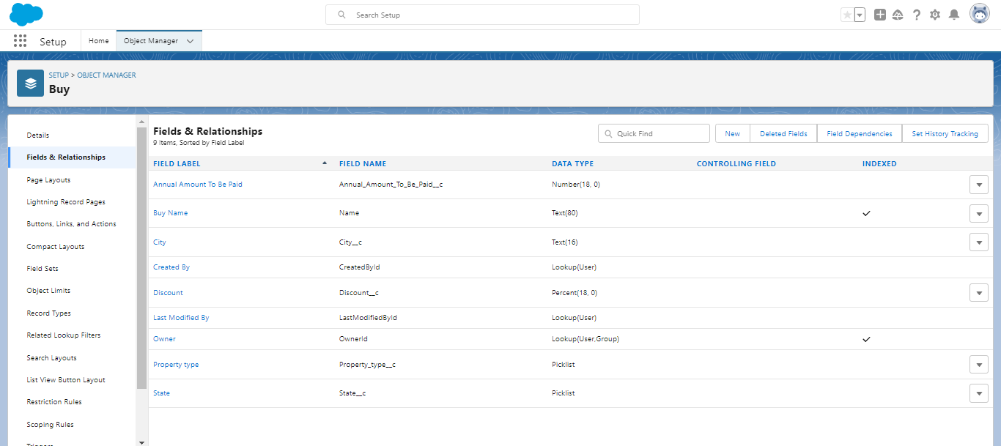

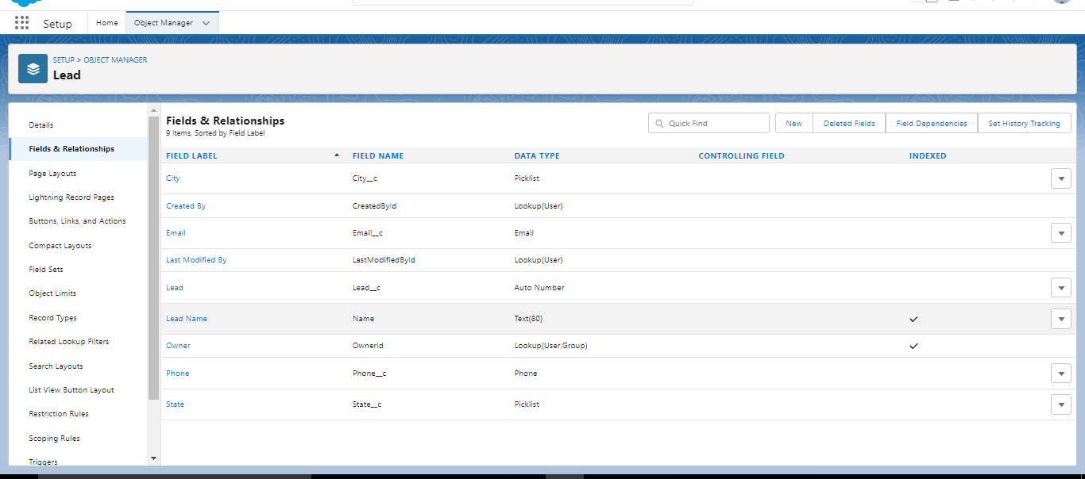­­­­­

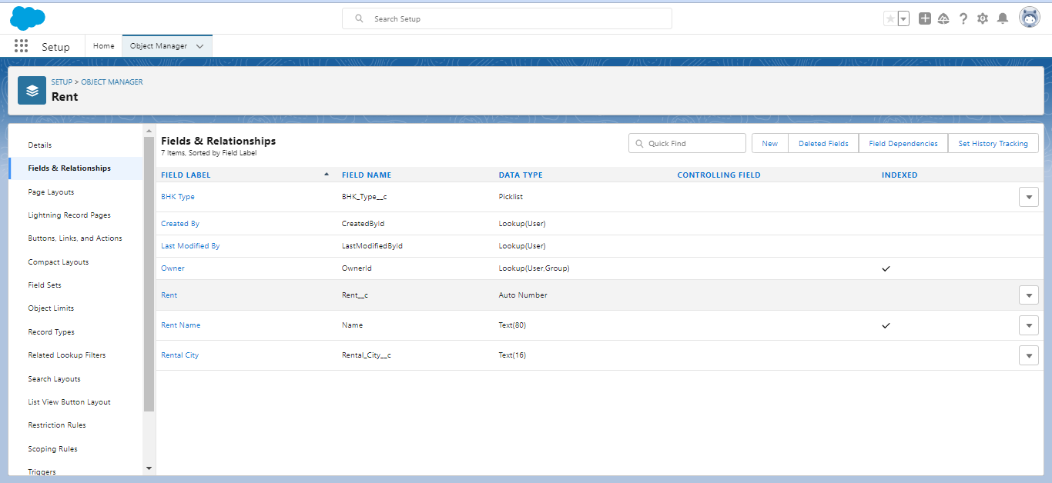

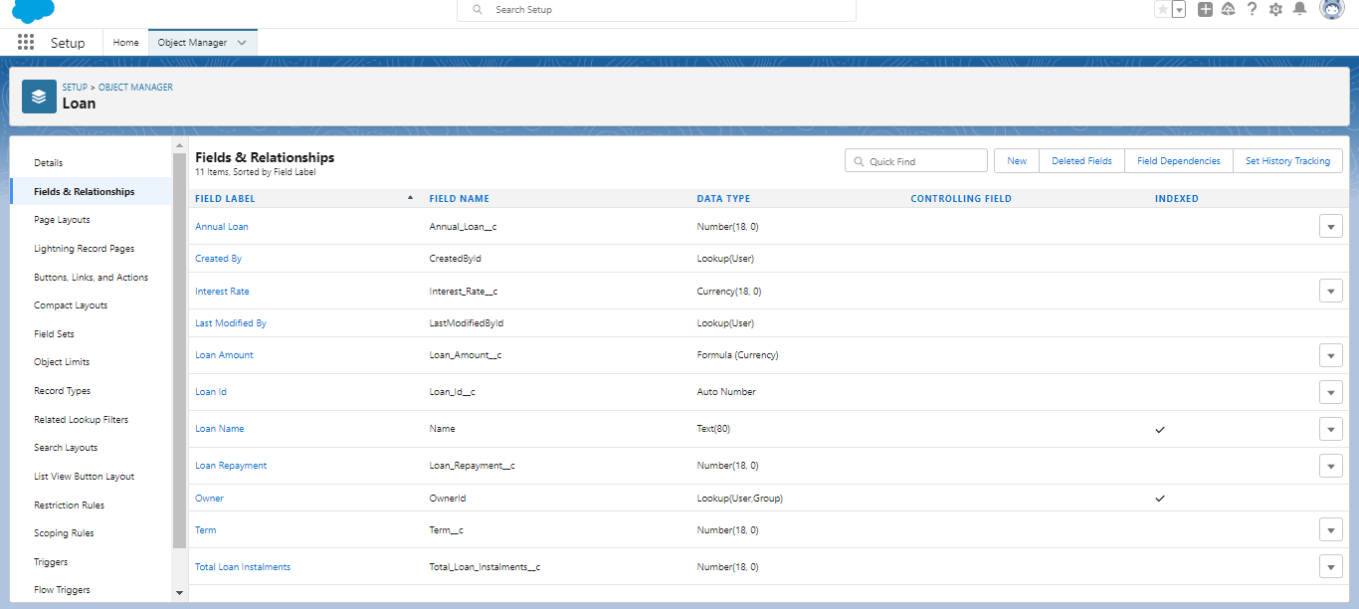

Milestone 6-Profile

*A profile is a group of settings and permissions that define what a user can do in sales force .

*The profile controls are Object permissions, Field permissions, User permissions, Tab settings,

App settings, Apex class access, Visual force page access, Page layouts, Record Types,

Login hours and Login IP ranges.

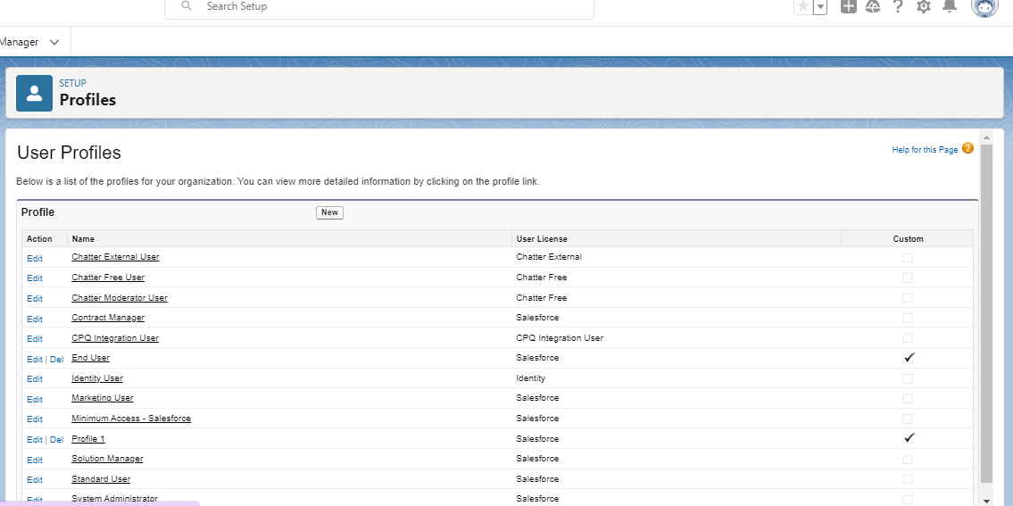

Milestone 7-New User

*A user is anyone who login to Sales force. Users are employees at your company, such

as sales representatives, managers, and IT specialists, who need access to the company's records.

* Every user in Sales force has a user account. The user account identifies the user, and the

user account settings determine what features and records the user can access.

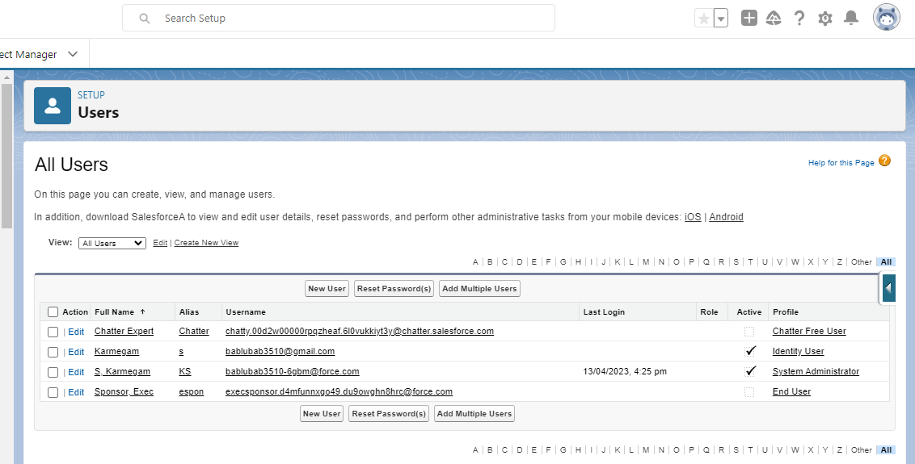

Milestone 8-Permission Set

*A permission set is a collection of settings and permissions that give users access to various tools and functions. Permission sets extend users' functional access without changing their profiles. Users can have only one profile but, depending on the Sales force edition, they can have multiple permission sets.

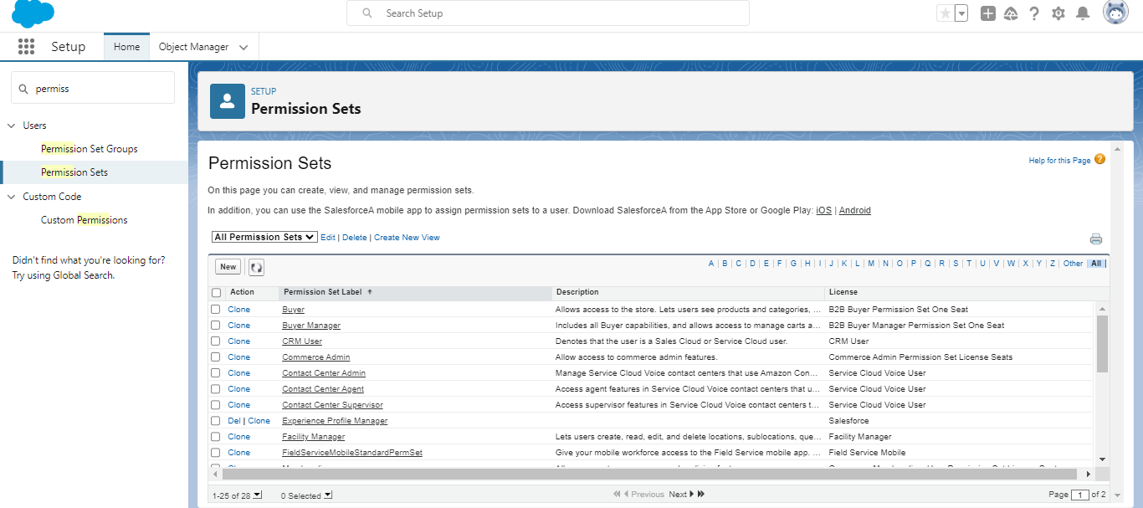

Milestone 9-Setup For OWD

Organization-Wide Defaults, or OWDs, are the pattern security rules that can follow for Sales force instance. Organization Wide Defaults are utilized to confine who can access what information in your CRM.

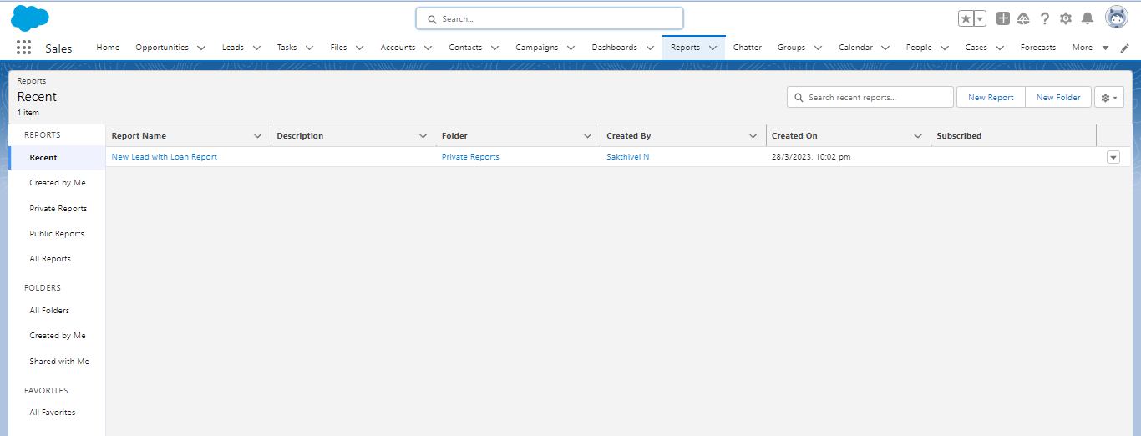

Milestone 10-Report

Reports give you access to your Sales force data. We can examine our Sales force data in almost

Infinite combinations, display it in easy-to-understand formats, and share the resulting insights

with others. Before building, reading, and sharing reports, review these reporting basics.

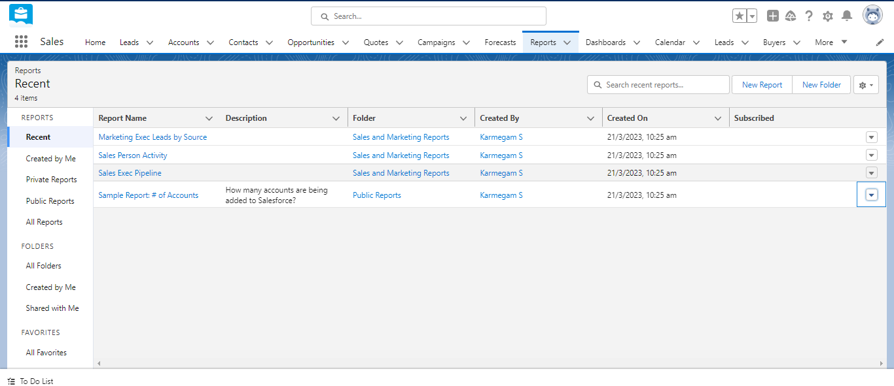

Milestone 11-Dashboards

Dashboards help us to visually understand changing business conditions so that we can make

decisions based on the real-time data we’ve gathered with reports. We have use dashboards to help users identify trends, sort out quantities, and measure the impact of their activities. Before building, reading, and sharing dashboards, review these dashboard basics.

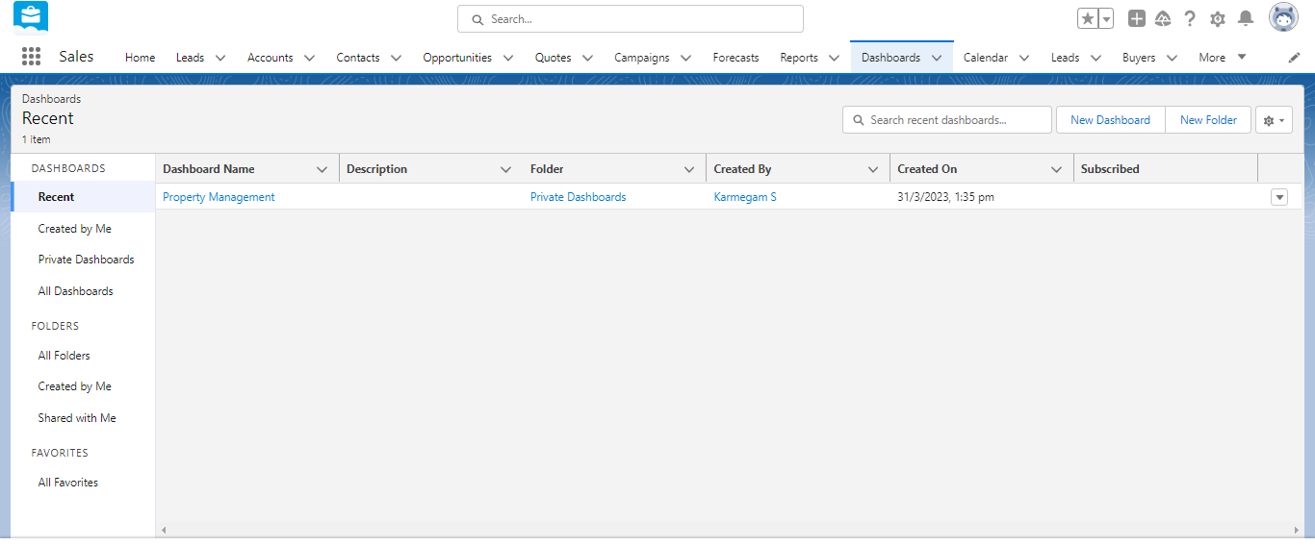

4 Trailhead Profile Public URL

Team Lead - <https://trailblazer.me/id/babls>

Team Member 1 - <https://trailblazer.me/id/kvengatachalam>

Team Member 2 - <https://trailblazer.me/id/rajvt10>

Team Member 3 –<https://trailblazer.me/id/akannan54>

5 ADVANTAGES

1 .New experience

2 .Gain my knowledge

3. Quick service

DISADVANTAGE

1. It will be time consuming

2. Team coordination will it cause in convenient

6 APPLICATIONS

1. Condominiums and Properties

2. Common Expense Management

3. Property management applications will communicate with third party service using REST web services.

4. Create our own custom application using APEX, visual force and out of the box features of sales force.

7 CONCLUSION

1. The property management helps properties owner their property as well as tenants searching for property to rent or lease.

2. The company focuses management and financial management, tenant and occupancy, facility management and administration.

3. The company targets customers in these market segmentations because of their unique needs.

4. We also target customers according to the mentioned segmentations methods to remain competitive and differentiate our services from competitors.

8 FUTURE SCOPE

1. Property management firms offer extensive home listings from which we may select properties with desired features.

2. Property managers schedule visits to the shortlisted home as per our preferred timings.

3. We can award access through different methods and it could be future scope (sharing principles, Role Hierarchy, Sales Teams, and Account groups, manual sharing, and so forth).